Alice Club Instructions (grades 5th and 6th 40 min introduction)

Open Alice folder which is located on the desktop (it takes a few minutes to open)
You can also download this for use at home for free by going to:
www.alice.org

There is a Welcome to Alice Screen that pops up just close that for now but notice that has a tutorial on it that is very good that you might want to take later.

Phase I – Set up your world

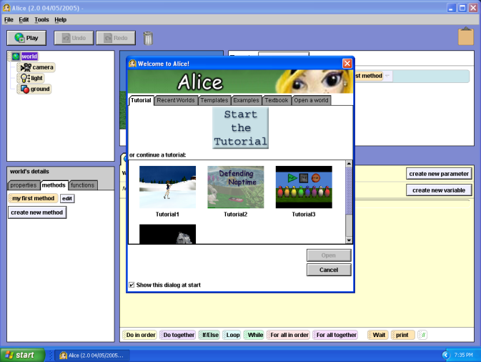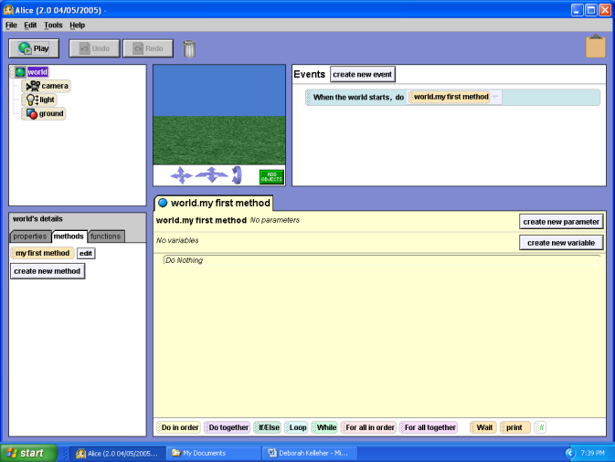
Template button
World Window

4 Sections to the window
- To begin click File, New World,
- Choose a template. You can choose a background for your world from the items listed
You will see a little picture in the top middle/right (World Window)
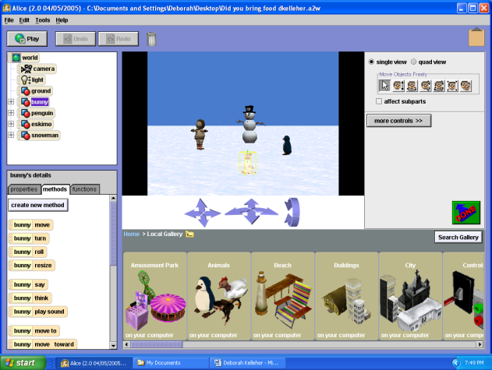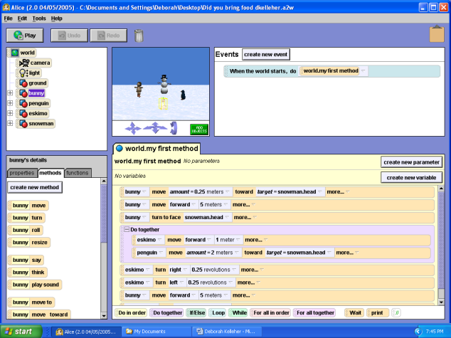
Done Button
Add Objects Button
Categories of objects
- Click the add objects button at the bottom right of the World Window.
It will bring a selection of different categories of objects near bottom of the Alice Window
- Scroll through and look at different options(use the scroll bar on bottom of the window to see more categories of objects)
- Pick an object that you want to add to your world
- Click and drag 3 different objects into your world
- On top right, there is bar which gives options of how to move item around – when you put your mouse on each button it will tell you what it will do…
- Click button and then take mouse to the picture and it will move picture in direction of the button you clicked
- Try each of the buttons
- Make one copy of each item (it is the last button)
- When you are done setting up your objects click on the Done on the top right side
Blocks to modify instructions
Editor
Tiles
Object Tree
Now look on top left section of the window. There is a list of items that are in your world (object tree). If you click on each item with right mouse button you will see list of options one option is methods…try some of these out.

Phase II Add Instructions (actions) to Your Objects
Click on object shown in the object tree which is at the top left
In the bottom left of the window you will see an area with 3 tabs: Properties, Methods, and Functions. Click on Methods tab and you will see a list of things this object knows how to do. (This is Details Area)
Go to the list and pick instructions and drag them over to right side of the list to the editor.

After you place instruction (a tile) in the editor area you can try out the instructions by clicking the play button (at the top left of the window)

Right mouse function click on dotted area of the tile and you can:
Delete an instruction
Copy an instruction

After you copy a tile click on dotted area of the tile line and move the tile to where you want it to be located.
After you copy a tile you can change the argument (for the tile)

At the bottom of the window are blocks that you can drag into the editor to modify how the instructions are executed.
Pick a “Do Together” and drag it to the editor and add two instructions that you want to happen at the same time.

(See “Did you bring food?” sample provided)

